MICROSOFT EDGE SETTING FOR LOGIN ISSUE WITH RD SERVICE
STEP-1
https://localhost:12121/pis - PUT THIS LINK ON THE SEARCH BAR
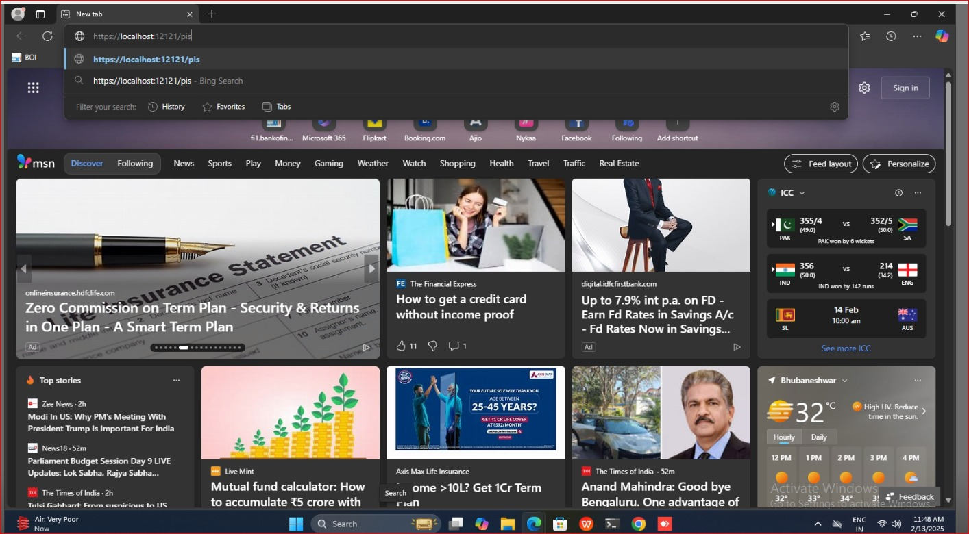

STEP-2
IT WILL APPEAR AS
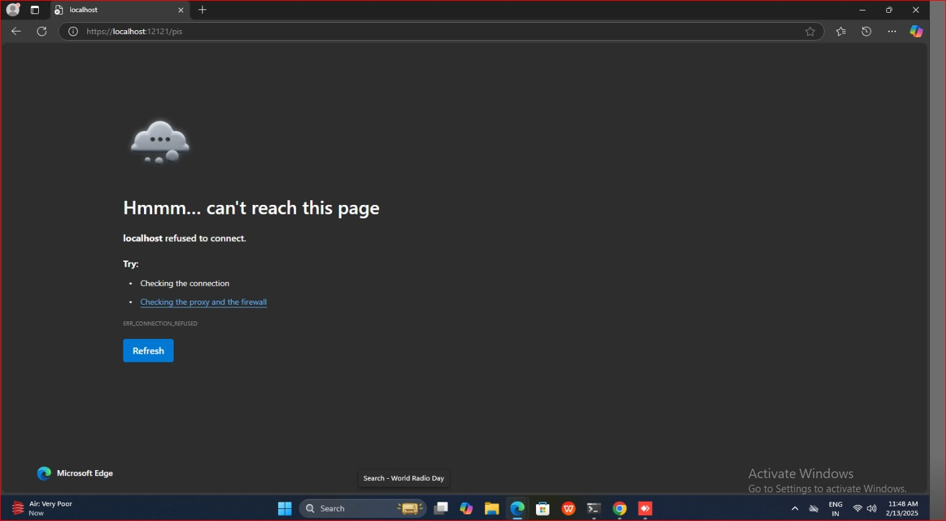

STEP-3
OPEN ANOTHR TAB AND SEARCH THIS LINK
https://127.0.0.1:11100/
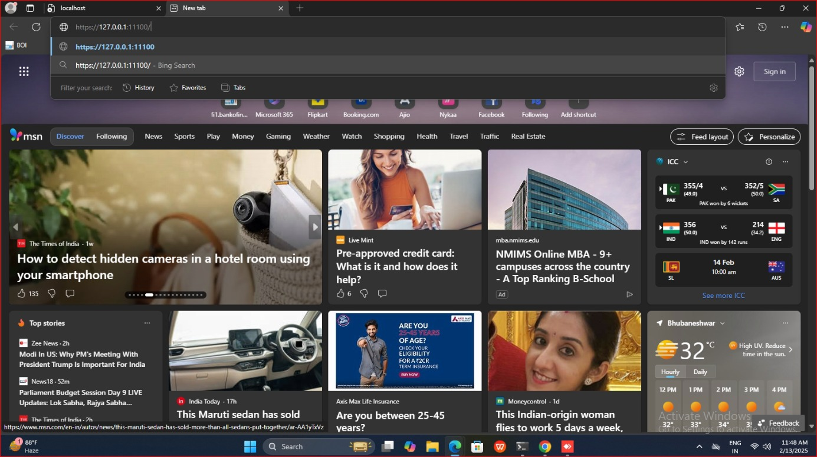
STEP- 4
THE PAGE WILL APPEAR LIKE
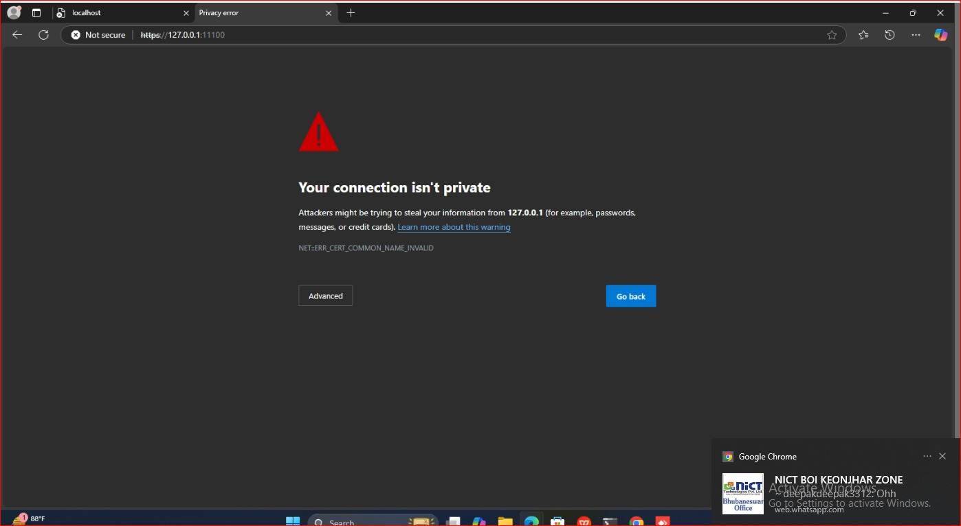
STEP-5
CLICK ON ADVANCE THEN PROCEED WITH CONTINUE TO 127.00 (UNSAFE)
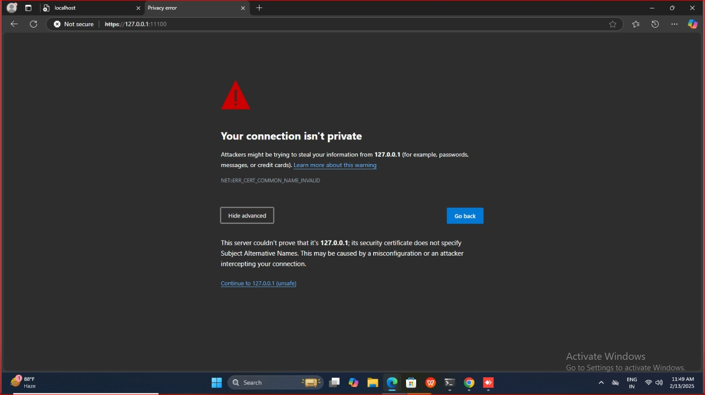

STEP- 6
CLOSE ALL THE TAB AND RE OPEN THE EDGE BROWSER
THEN TYPE- EDGE://FLAGS AND THEN ENABLE THE 4 OPTION MENTION BELOW
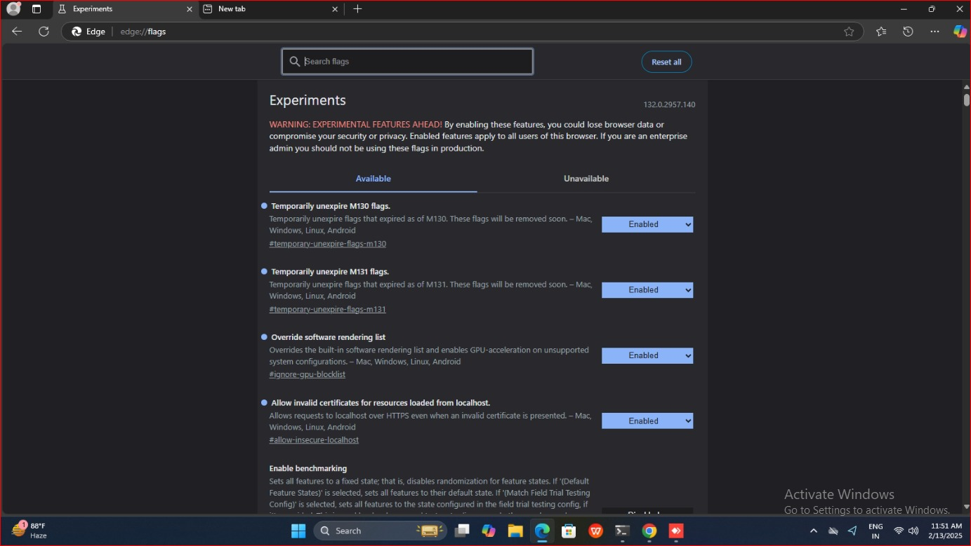

IF OPTION 4 IS NOT SHOWING THEN RESTART YOUR SYSTEM AND THEN LOGIN WITH YOUR ID

EVEN AFTER THE EDGE SETTING YOU ARE FACING RD SERVICE ISSUE THEN CONTINUE WITH THE CHROME SETTING
GOOGLE CHROME SETTING FOR LOGIN ISSUE WITH RD SERVICE
STEP-1
https://localhost:12121/pis - PUT THIS LINK ON THE SEARCH BAR
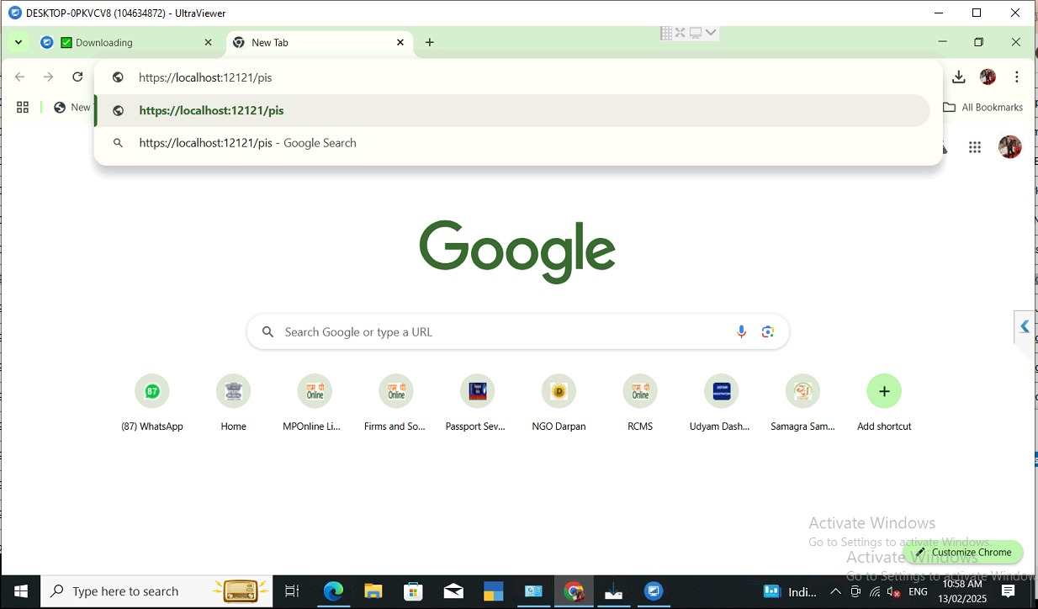
STEP-2
IT WILL APPEAR AS
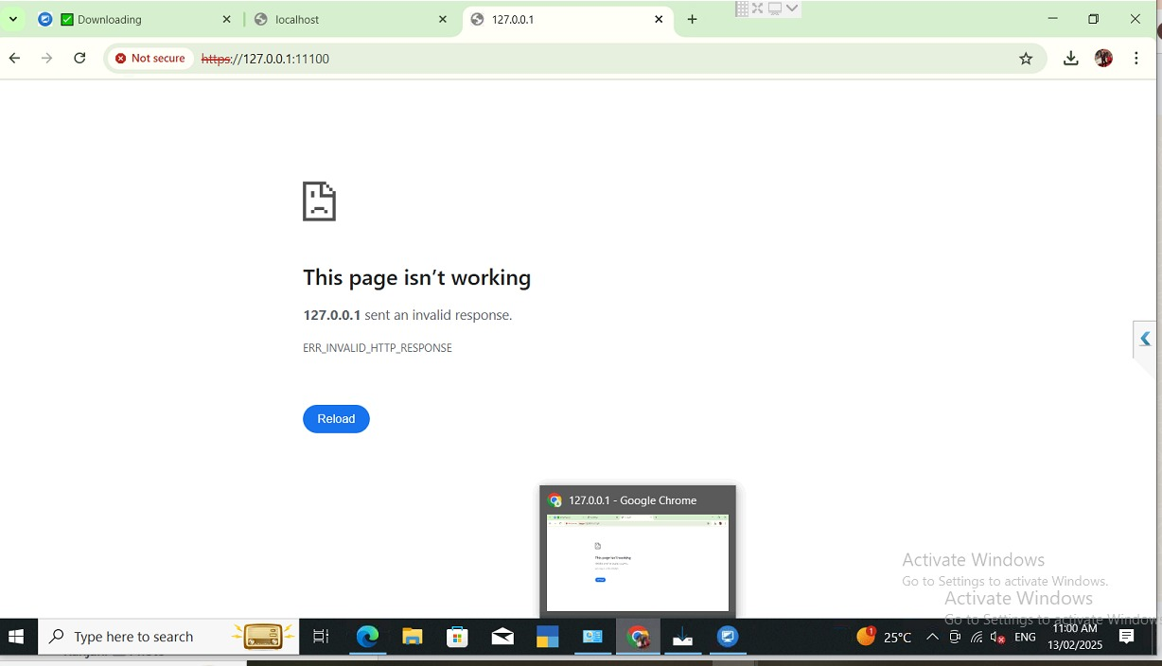

STEP-3
OPEN ANOTHR TAB AND SEARCH THIS LINK
https://127.0.0.1:11100/
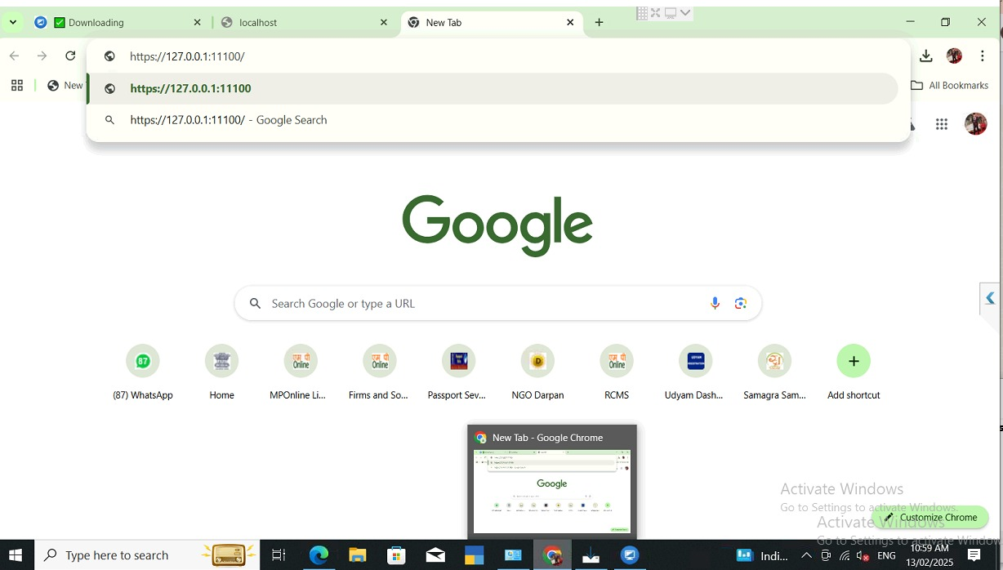
STEP- 4
THE PAGE WILL APPEAR LIKE
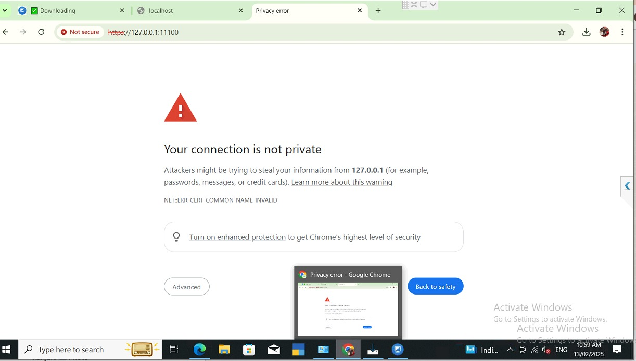

STEP-5
CLICK ON ADVANCE THEN PROCEED WITH CONTINUE TO 127.00 (UNSAFE)
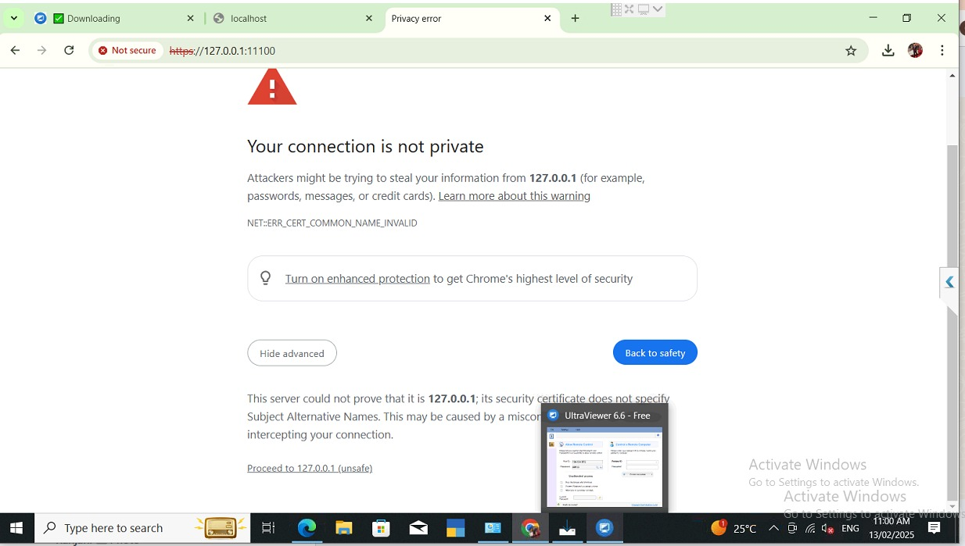

STEP- 6
CLOSE ALL THE TAB AND RE OPEN THE EDGE BROWSER
THEN TYPE- CHROME://FLAGS AND THEN ENABLE THE 4 OPTION MENTION BELOW
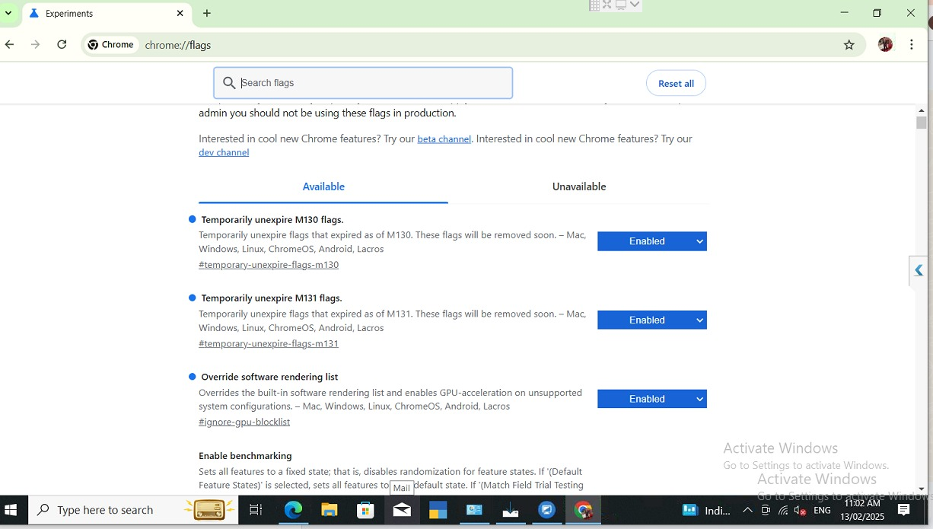
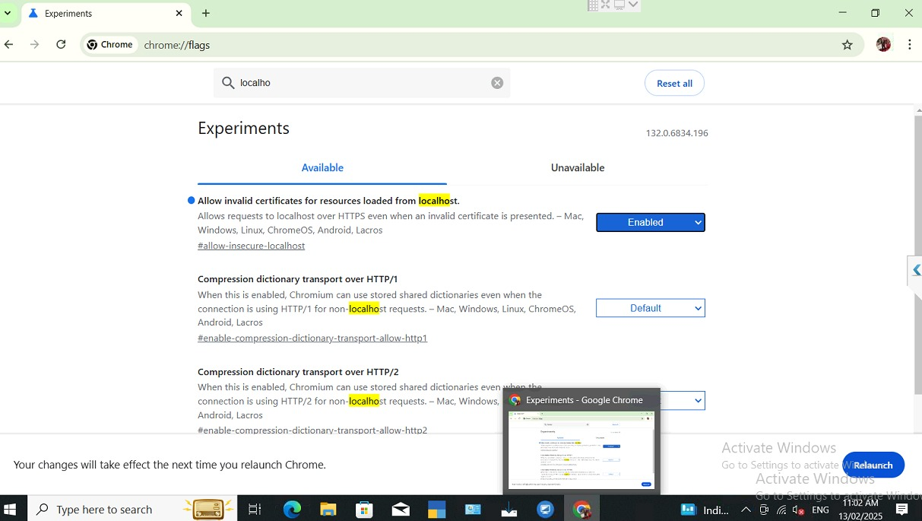

STEP-7
AFTER ALL THE SETTING RE OPEN THE BROWSER AND SEARCH FOR THE BANK OF INDIA LINK
https://fi1.bankofindia.co.in
ALLOW THE POP-UP AND REFRESH THE PAGE
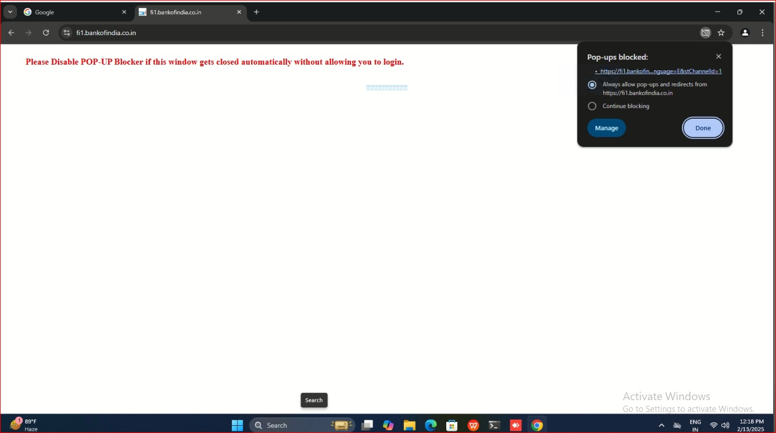

STEP-8
BOOKMARK THE TAB WHILE CLICKING THE STAR 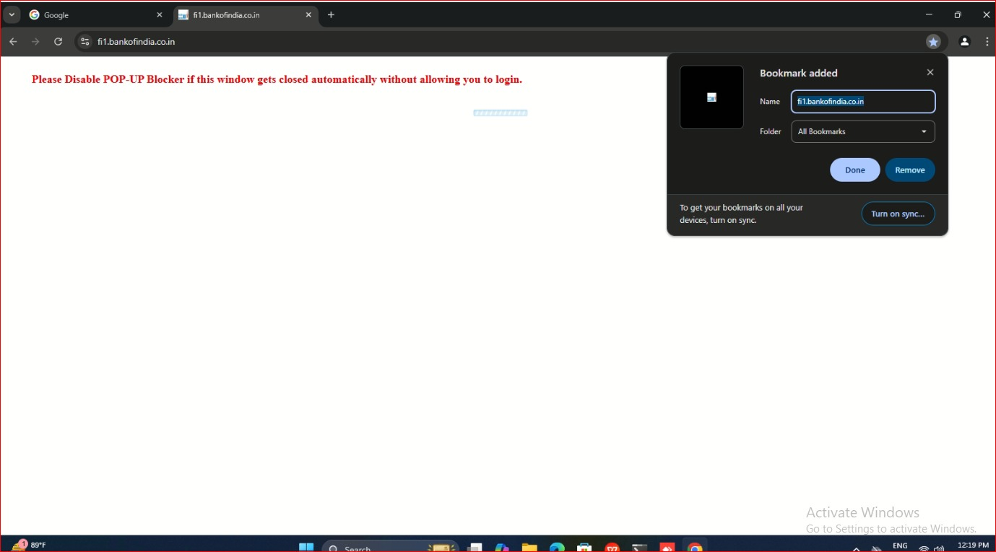

YOU ARE READY TO LOGIN

